Кабель для сопряжения клавиатуры CK-04 и Evalution board Altera DS1 GPIO1

|  |  |  |  |  |  |  |
| --- | --- | --- | --- | --- | --- | --- |
| шлейф | NAMES | GPIO1 | NAMES | GPIO_W | BANK | GPIO_0 |
| 1 | 1 | 32 | IO_A27 | GPIO_B27 | J22 | 27 |
| 2 | 2 | 33 | IO_A28 | GPIO_B28 | K21 | 28 |
| 3 | 3 | 34 | IO_A29 | GPIO_B29 | K22 | 29 |
| 4 | 4 | 35 | IO_A30 | GPIO_B30 | J19 | 30 |
| 8 | A | 36 | IO_A31 | GPIO_B31 | J20 | 31 |
| 9 | B | 37 | IO_A32 | GPIO_B32 | J18 | 32 |
| 10 | C | 38 | IO_A33 | GPIO_B33 | K20 | 33 |
| 11 | D | 39 | IO_A34 | GPIO_B34 | L19 | 34 |
| 12 | E | 40 | IO_A35 | GPIO_B35 | L18 | 35 |
|  |  |  |  |  |  |  |

<http://www.ceb.ru/2_Klav/2_2.htm#ck04>

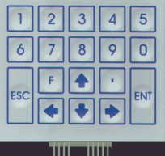 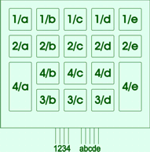

NAMES

F1-F5 = F1-F5

F+< = Bksp

F+ . = Del